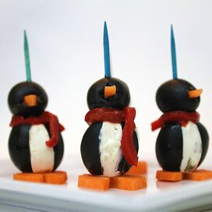

**Cream Cheese Penguins**

**Ingredients:**

18 jumbo black olives, pitted

1 (8 ounce) package cream cheese, softened

18 small black olives

1 carrot

Pimento

**Directions:**

1. Cut a slit from top to bottom, lengthwise, into the side of each jumbo olive. Carefully insert about 1 teaspoon of cream cheese into each olive. Slice the carrot into eighteen ¼ inch thick rounds; cut a small notch out of each carrot slice to form feet. Save the cut out piece and press into center of small olive to form the beak. If necessary, cut a small slit into each olive before inserting the beak.
2. Set a big olive, large hole side down, onto a carrot slice. Then, set a small olive onto the large olive, adjusting so that the beak, cream cheese chest and notch in the carrot slice line up. Secure with a toothpick. Place thin slices of pimento between head and body.

**Nutrition Facts (Per Serving)**

Calories 57 Prep: 30 minutes

Protein 1 g (2% DV) Additional: 5 minutes

Carbohydrates 1.2 g (% DV) Total: 35 minutes

Fat 5.5 g (9% DV) Servings: 18

Cholesterol 13.7 mg (5% DV) Yields: 18 penguins

Sodium 104.2 mg (4% DV)